Instruction manual for writing boards with melamine finish

1. Classification and instructions for the use of writing boards with a melamine finish

|  |  |  |  |  |  |  |
| --- | --- | --- | --- | --- | --- | --- |
| Category | Product Pictures | Product Size | thicknesses | substrates | surface brightness | Description of Product Use |
| High Glossy white |  | 1220*2440mm | 3mm  5mm  8 MM  9mm  18mm | MDF and  PB | 108  ~  116 | With a dry erase function of the melamine finish high-gloss white writing whiteboard, mainly used for making: office meetings, training whiteboard, desk screen book memo writing, practice writing with small stationery board, etc.. Writing stationery: water-based black whiteboard pen |
| Grid line white board |  | 1220*2440mm | 3mm  5mm  9mm | MDF | 108  ~  116 | With dry erase function of melamine finish high-gloss field grid white background writing board, mainly used for making: teaching and practicing writing Chinese characters stationery board production. Writing stationery: water-based black whiteboard marker. |
| Dot line grid white board |  | 1220*2440mm | 3mm  5mm  9mm | MDF | 108  ~  116 | The writing board with dry erase function has a melamine finish high-gloss red and blue lines on a white background and is mainly used for the production of: the teaching of pinyin and English and writing practice of stationery board production. Writing stationery: water-based black whiteboard pen |
| Matt black |  | 1220*2440mm | 3mm  5mm  9mm  18mm | MDF | 7  ~  9 | Writing boards with dry-erase function, with a matte matte black base in melamine finish, mainly used for making: large blackboards for traditional teaching and small blackboards for practicing chalk writing. Writing stationery: white chalk |
| Green matt |  | 1220*2440mm | 3mm  5mm  9mm  18mm | MDF | 7  ~  9 | Writing boards with dry-erase function, with a matte matte finish on a dark green background in a melamine finish, mainly used for the production of: writing boards for traditional teaching and small stationery boards for practicing chalk writing. Writing stationery: white chalk |

1. Product quality standards for writing boards with melamine finish

|  |  |  |  |  |  |  |  |
| --- | --- | --- | --- | --- | --- | --- | --- |
| Pseudolaric acid | Product Quality Requirements | | | | | | |
| Requirements for cosmetic defects | Thickness Tolerance | Brightness Requirements | environmental rating | Density requirements | Nail Grip Requirements | Dry Erase Requirements |
| High-gloss white writing board | 1. The surface is flat, without black spots, black spots, impurities, indentations, scratches wavy lines, voids, uneven luster, bubbles, bulges, and paper defects. | ±0.2mm | 108  ~  116 | in line with  National standard E1 and above | PB substrate requirement 730-760Kg/m3 MDF substrate requirement 860-920Kg/m3 | Writing board grip screw force: board surface ≥ 800N, board edge ≥ 500N | 1. Dry erase does not allow leaving obvious pinhole-like handwriting residue. Pinhole diameter of less than 0.05mm, and pinhole do not dense distribution, and repeated rubbing 3 times, in natural light conditions, without the use of amplifiers, to 1.0m distance shall prevail observation, no visible lack of depression point within ten seconds is considered qualified.  2. If the board is visually inspected within 0.8 meters, there are no obvious traces of writing on it can be left off the record (in normal light and at multiple angles).  3. If the primary test effect involves residual handwriting residue, the Delta E value (measured by a spectrophotometer), which reflects the degree of coloration of the panel's handwriting and which excludes pinhole-like handwriting residue, must be measured and recorded.  4, to ensure that the test with a dry erase pen dry erase performance is good, dry erase pen ink is very little to be replaced, otherwise it will affect the dry erase effect, dry erase pen writing immediately after the erase, sometimes there will be erase not clean, so the test to be written after the ink to dry and then erase, normal dry erase test after the board left behind ghosting with anhydrous ethanol erase test clean is considered to be qualified. |
| High-gloss red and blue line writing board |
| High-gloss field grid writing board |
| matt Black Writing Board | 7  ~  9 | 1. The chalk writing is smooth and clear, and the chalk on the board surface can fall off automatically without residue after wiping with a chalk eraser. |
| Frosted Green Writing Tablet |

1. Price Breakdown for melamine Finish Writing Boards

|  |  |  |  |  |  |  |
| --- | --- | --- | --- | --- | --- | --- |
| serial number | Item name | environmental rating | sizes | unit (of measure) | ex-factory price | note |
| 1 | 3mm MDF double-sided glossy white writing board | E1 | 4*8 | USD/sheet | 9.8 | For red and blue line and field grid models add $0.5/sheet to the white price. |
| 2 | 5mm MDF double-sided glossy white writing board | E1 | 4*8 | usd/sheet | 12.3 |
| 3 | 9mm MDF double-sided glossy white writing board | E1 | 4*8 | usd/sheet | 15.2 |
| 4 | 8mm PB Double Sided Glossy White Writing board | E1 | 4*8 | usd/sheet | 14.2 |
| 5 | 18 mmMDF single glossy/single linen white writing board | E1 | 4*8 | usd/sheet | 22.5 |
| 6 | 18 mmPB Single Glossy/Single Linen White Writing board | E1 | 4*8 | usd/sheet | 21.3 |
| 7 | 3mm MDF Single Side Frosted Black/Single Gray Washi Writing Board | E1 | 4*8 | usd/sheet | 7.1 |  |
| 8 | 5mm MDF Single Side Frosted Black/Single Gray Washi Writing Board | E1 | 4*8 | usd/sheet | 8.5 |  |
| 9 | 3mm MDF Single Side Frosted Green/Single Gray Washi Writing Board | E1 | 4*8 | usd/sheet | 7.9 |  |
| 10 | 5mm MDF Single Side Frosted Green/Single Gray Washi Writing Board | E1 | 4*8 | usd/sheet | 9.35 |  |

Note: If the environmental grade requirements for P2 in the original price based on an increase of 0.2 usd / sheet. The above prices include the cost of export wood pallet packaging.

(If there are customers requesting to do one side glossy/single side normal melamine, it can be cheaper by 1usd on top of the double glossy)

1. package of the board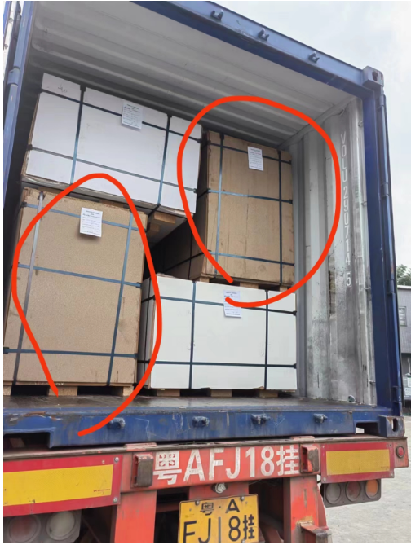

Yueshan decoration industry co.,ltd.